Meal Prep Week 4
Recipes by Vincent Esposito, Ms, DC

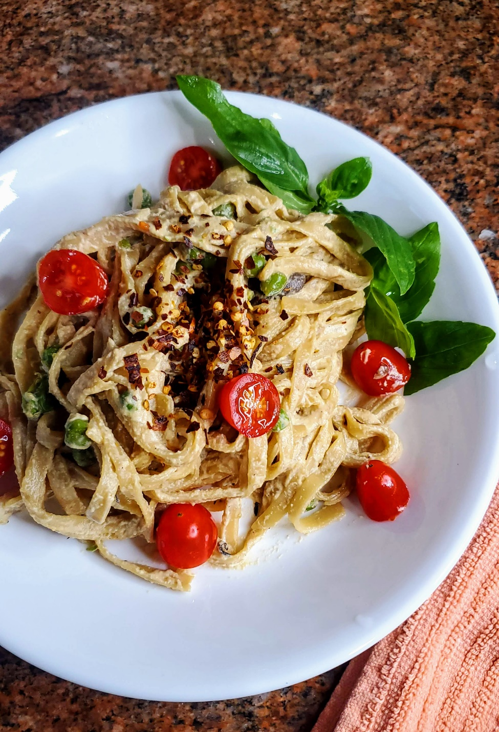

Suggested Meal Planner
WEEK OF: | BREAKFAST | LUNCH | DINNER
MONDAY | Beet & Orange Smoothie | Quick Vegan Chana Masala | Vegan Carbonara
TUESDAY | Island Sweet Potato Smoothie Bowl | Vegan Carbonara | Sheet Pan Sweet Potato Fajitas
WEDNESDAY | Spicy Ginger Turmeric Mango Smoothie | Quick Vegan Chana Masala | Mediterranean Quinoa Bowls
THURSDAY | Island Sweet Potato Smoothie Bowl | Sheet Pan Sweet Potato Fajitas | Portobello Mushroom & Asparagus Tacos with Avocado Jalapeno Crema
FRIDAY | Cranberry Orange Smoothie Bowl | Portobello Mushroom & Asparagus Tacos with Avocado Jalapeno Crema | Mediterranean Quinoa Bowls

BONUS: Apple Cinnamon Baked Oats

Lunch & Dinner Grocery List

- 1 Beet
- 5 cups Plant Milk
- 2 Oranges
- 1 Zucchini
- 5 Bananas
- 1 cup Roasted Sweet Potato
- 4 cups Mango
- 1 cup Pineapple
- Ginger 2 ½ t
- ¼ cup Cashews
- ½ cup Cranberries
- ½ cup Apple Sauce
- 3 Apples
- 2 Red Onion
- 3 15oz. Chickpeas
- 15oz. Diced Tomatoes
- 3 heads Garlic
- 2-3 Chili Peppers
- 1 ½ cup Chickpea Flour
- 2 cups Vegetable Stock

- 2 cups Assorted Vegetables of choice
- 5 cups Sweet Potato
- 3 Lemons
- 1 Yellow Onion
- 1 bunch Asparagus
- 1 bunch Spinach
- 1 lb Portobello Mushrooms
- 1 Avocado
- 1 Lime
- 6-8 Tortillas
- 2 cups Peas
- 2 Shallots
- ¼ cup Basil
- ¼ cup Mint
- 1 Carrot
- 2 Bell Peppers
- 2 Kirby Cucumbers

- 2 cups Cherry Tomatoes
- ¼ cup Kalamata Olives

BREAKFAST IDEAS

Beet & Orange Smoothie
Serves 1
Cook and Prep Time: 5 minutes
You Need:
- 1 cup Plant Milk
- 1 Beet, chopped
- 1 Navel Orange, chopped
- 1 cup Zucchini, chopped
- 1 Banana, chopped
- 1 T Chia Seeds
- 1 T Hemp Seeds

DIRECTIONS
- Clean and prep the ingredients as necessary.
- Add all ingredients to blender.
- Pulse until smooth. Enjoy!

Island Sweet Potato Smoothie Bowl
Cook and Prep Time: 5 minutes
Serves: 2
You Need
- ¾ cup Roasted Sweet Potato
- 2 Bananas, sliced
- ½ cup Mango, chopped
- ½ cup Pineapple, chopped
- ½ cup Rolled Oats
- ¼ cup Plant Milk of choice
- 1 t Cinnamon
- 1 t Vanilla Extract
Toppings*
- 1 T Nuts or Seeds of Choice
- Chopped Mango
- Chopped Kiwi
- 1 t Chia Seeds
- 1 T Desiccated Coconut
- 1 T Nut Butter of choice
*Feel free to mix and match toppings as you see fit!
DIRECTIONS
- To a blender, add roasted sweet potato, bananas, mango, pineapple, rolled oats, cinnamon, and vanilla extract. Add more milk if necessary, but you want the mixture to be very thick.
- Place the mixture in a bowl. Top with your desired toppings.
- Serve and eat immediately. Enjoy!

Spicy Ginger Turmeric Mango Smoothie
Serves 2
Cook and Prep Time: 5 minutes
You Need:
- 3 cups Mango
- 1 ½ t Ground Turmeric
- 1 t Fresh Ginger, grated
- ¼ cup Cashews, soaked overnight OR Coconut Cream
- 1 Carrot, chopped or shredded
- 1 ½ cups Coconut Water OR Plant Milk
- 1 T Chia Seeds
- 1 T Hemp Seeds

DIRECTIONS
- Clean and prep the ingredients as necessary.
- Add all ingredients to blender.
- Pulse until smooth. Enjoy!

Cranberry Orange Smoothie Bowl
Cook and Prep Time: 5 minutes
Serves: 1
You Need
- ½ cup Cranberries
- 1 Orange, sliced
- 1 Frozen Sliced Banana
- 2 T Plant Milk of Choice
- 1 T Cashew Butter or Nut Butter of choice
Toppings*
- 1 T Nuts or Seeds of Choice
- 1 T Dried Fruit
- Fresh Fruit of choice
- 1 t Chia Seeds
- 1 T Desiccated Coconut
- 1 T Nut Butter of choice
*Feel free to mix and match toppings as you see fit!
DIRECTIONS
- To a blender, add bananas, cranberries, orange, cashew butter, and plant milk. Add more milk if necessary, but you want the mixture to be very thick.
- Place the mixture in a bowl. Top with your desired toppings.
- Serve and eat immediately. Enjoy!

Apple Cinnamon Baked Oats
Cook and Prep Time: 50 minutes
Serves: 8
You Need
- 2 ½ cups Rolled Oats
- 2 T Ground Flax Seeds + 6 T Water
- ½ cup Apple Sauce
- 1 t Vanilla Extract
- 1 Banana, mashed
- 2 T Maple Syrup
- 2 cups Plant Milk
- 2-3 Apples of Choice, diced
- ½ cup Almonds, chopped
Toppings
- Pecans, Almonds, or other Nuts
- Dried Fruit
- Fresh Apple Slices
- Nut Butter
DIRECTIONS
- Rinse and chop the produce accordingly. Preheat your oven to 375˚F. Line 1 deep baking dish
- Make the flax egg by mixing ground flax and water, and setting aside for 10 minutes.
- In a large bowl combine all of your ingredients (except the toppings) and mix well.
- Add the mixture to your baking tray, and bake for 40-45 minutes, or until a toothpick can come out clean.
- Once finished, let the oats cool for 5-10 minutes before serving. Add your desired toppings, and enjoy!

Quick Vegan Chana Masala
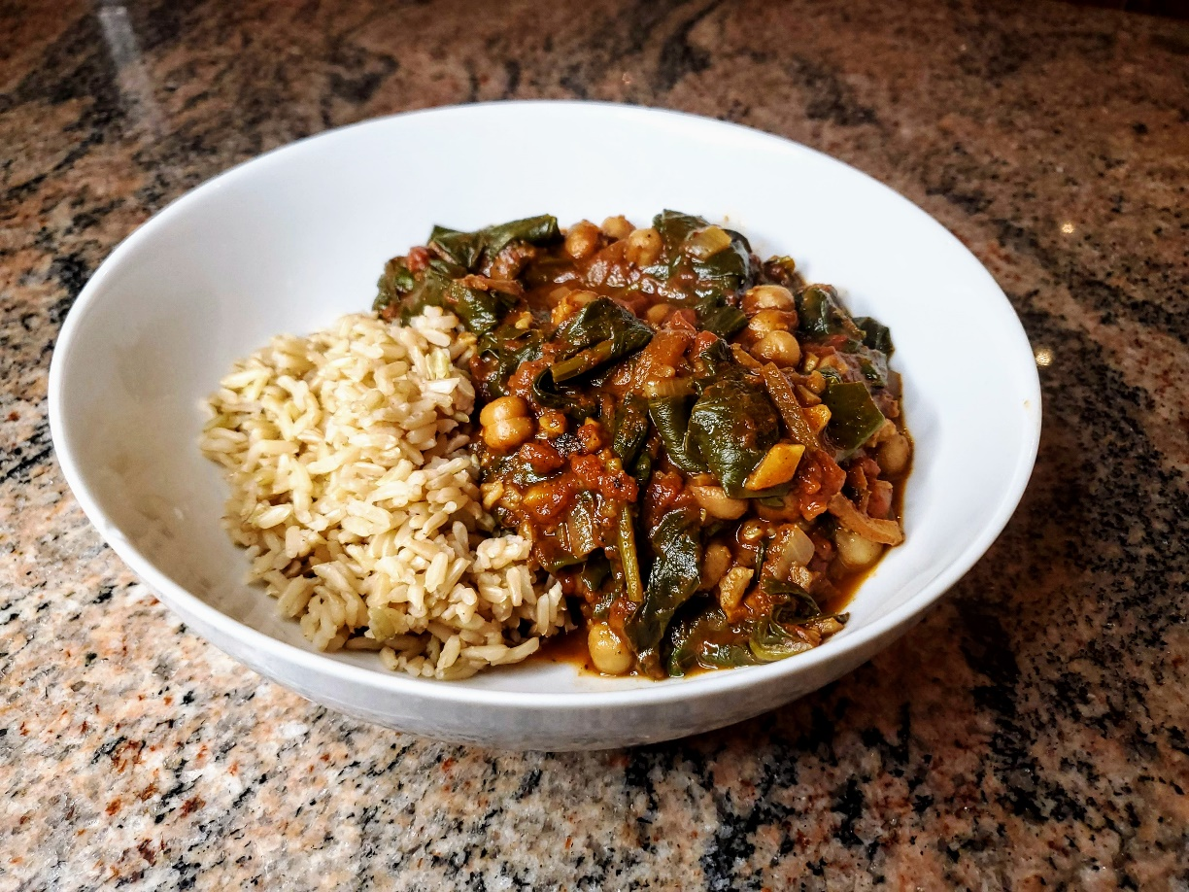
Cook and Prep Time: 40 minutes
Serves: 3-4
You Need
- 1 Red Onion, halved and cut thinly into half-moons
- 1 15oz. Chickpeas, rinsed and drained
- 1 15oz. Pureed OR Diced Tomatoes
- 1 cup Vegetable Stock OR Water (add more if you want a thinner dish)
- 1 tbsp. Ground Cumin
- 1 head Garlic, minced
- 2 tbsp. Fresh Ginger, minced
- 1/2 cup Chopped Cilantro, for garnish
- 2-3 fresh green chilies, sliced with seeds (optional)
- 1 tbsp. Ground Cloves
- 1 tbsp. Coriander
- 1 tbsp. Turmeric
- Salt, to taste
- Black Pepper, to taste
- Vegetable Stock or 1 t Extra Virgin Olive Oil
DIRECTIONS
- Rinse and chop the produce accordingly.
- Set a pot to medium heat. Once hot, add coconut oil. Then, add ginger, garlic, and red onion, stirring frequently to avoid burning. Cook until onion is translucent, 4-5 minutes.
- Add chiles, and cook for 1 minute more.
- Add tomatoes, vegetable stock, and chickpeas. Add all spices and bring mixture to a boil. Then cover and reduce heat to a simmer. Season with salt and pepper. Cook until thickened, 5-6 minutes.
- Remove from heat. Serve with rice. Garnish with fresh cilantro. Enjoy!

Vegan Carbonara
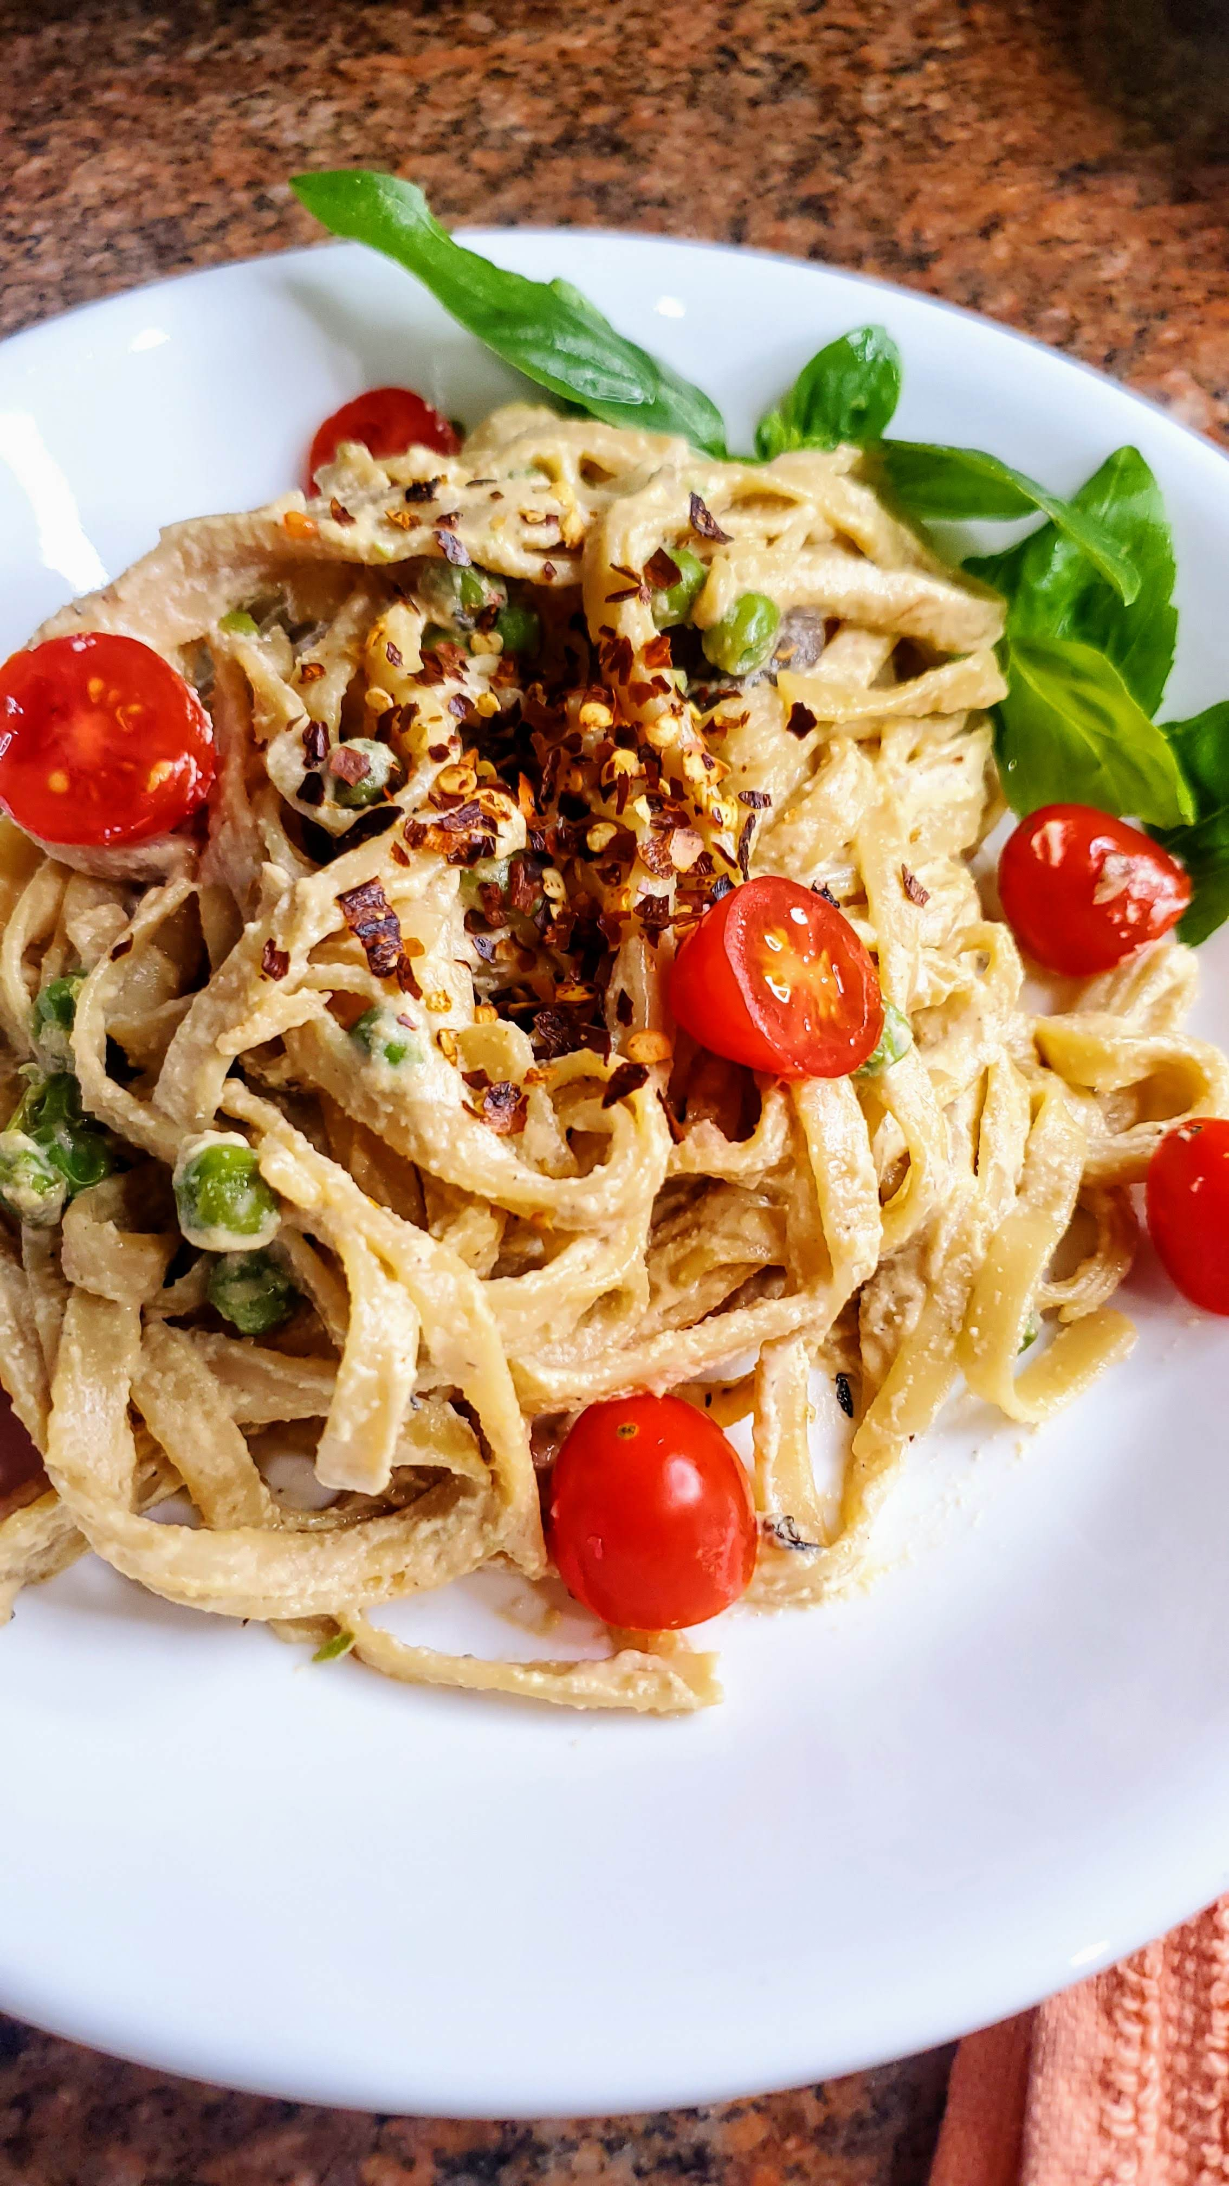
Cook and Prep Time: 25 minutes
Serves: 4
You Need
- 1lb Spaghetti or Linguine (Brown Rice or Lentil/Chickpea Base)
- 1lb. Mushrooms, sliced
- 1 ½ cups Peas
- 6-8 cloves Garlic, sliced
- Salt & Pepper, to taste
For the Sauce
- 1 ½ cup Cashews, soaked overnight
- 1 ¾ cups Water or Vegetable Stock
- ½ cup Nutritional Yeast
- 1 T Tamari
- 1 t Smoked Paprika
- Salt & Pepper, to taste
For Serving
- Arugula Salad
- Red Chili Flakes
- Chopped Parsley
- Chopped Basil
- Chopped Cherry Tomatoes
DIRECTIONS
- Rinse and chop the produce accordingly.
- Cook the pasta according to package instructions.
- Set a large skillet to medium heat. Once hot, add the mushrooms, and cook for 7-8 minutes, until soft and browned. Then add the garlic, and cook for 1 minute more. Then, add the peas, and cook until warmed through.
- Make the sauce. Combine all of the sauce ingredients in a blender, and pulse until smooth.
- Add the sauce and cooked pasta, and toss to combine. Add water to thin if needed, and season to taste.
- Serve with your desired toppings. Enjoy!

Sheet Pan Sweet Potato Fajitas
Cook and Prep Time: 50 minutes
Serves: 3-4
You Need
- 5 cups Sweet Potatoes, cut into matchsticks
- 1 Red Onion, sliced
- 2 Bell Peppers, sliced
- 1 T Extra Virgin Olive Oil OR Vegetable Stock
- 1 T Smoked Paprika
- 2-3 t Ground Cumin
- 1 T Garlic Powder
- 2-3 t Onion Powder
- 1-2 Dried Oregano
- 1 T Chili Powder (adjust to taste)
- Salt & Pepper, to taste
For Serving
- Cooked Black Beans
- Cooked Rice or Quinoa
- Guacamole
- Corn Tortillas
- Lime Wedges
- Cilantro
DIRECTIONS
- Rinse and chop the produce accordingly. Preheat your oven to 400˚F. Line 2 baking trays.
- Mix the spices in a bowl.
- Add your sweet potatoes to 1 of the baking trays. Toss with ½ of the oil (or vegetable stock) and ½ of the spice mix. Season with salt and pepper to taste. Roast the potatoes for 35-40 minutes, tossing halfway.
- To the second baking tray, add the bell peppers and onion. Toss with the other ½ of oil and spices. Season to taste. Roast for 20-25 minutes, flipping halfway.
- While the vegetables roast, make your black beans, grain of choice, and/or guacamole.
- Assemble and enjoy!

Mediterranean Quinoa Bowls

Cook and Prep Time: 30 minutes
Serves: 3-4
You Need
- ¾ cup Quinoa + 1 ½ cup Vegetable Stok or Water
- 20 oz. Chickpeas, rinsed and drained
- 2 Kirby (Mini) Cucumbers
- 1 cup Cherry Tomatoes, sliced
- ¼ cup Red Onion, diced
- ¼ cup Kalamata Olives, pitted and chopped
For the Dressing
- 1 T Tahini
- 1 Lemon, juiced
- 1-2 t Dried Oregano
- 1-2 t Dried Thyme
- Water, as needed
- Salt & Pepper, to taste
For Serving
- Lemon Wedges
- Hummus
- Chopped Parsley
- Kalamata Olives
DIRECTIONS
- Rinse and chop the produce accordingly.
- Cook the quinoa. Add the quinoa and vegetable stock (or water) to a bowl. Bring to a boil, then cover and reduce heat to a simmer. Cook for 20 minutes, or until the water has evaporated and the quinoa is tender. Then, fluff with a fork and allow to cool.
- Make the dressing. Add all of the dressing ingredients to a bowl, and whisk to combine.
- Distribute the quinoa in each bowl. Add the tomatoes, cucumber, chickpeas, red onion, Kalamata olives, and desired toppings.
- Pour over the dressing, and enjoy!

Portobello Mushroom & Asparagus Tacos with Avocado Jalapeno Crema
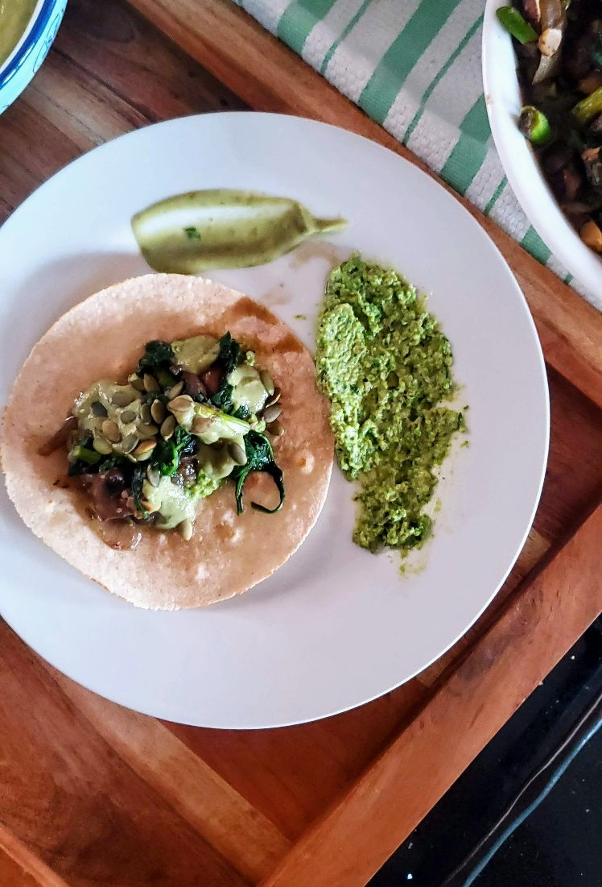
Cook and Prep Time: 40 minutes
Serves: 4
You Need
For the Tacos:
- 1 Yellow Onion, sliced
- 5-6 cloves Garlic, sliced
- 1 bunch Asparagus, cut into 1-inch pieces
- 1 bunch Spinach, stems removed
- 1lb Portobello Mushrooms, sliced
- Salt & Pepper, to taste
- Vegetable Stock or 1 t Extra Virgin Olive Oil, for sautéing
- Pea, Basil, and Mint Spread [OPTIONAL](see below)
For the Crema:
- 1 Avocado
- ¼ c Water
- Juice on 1 Lime
- ½ cup Cilantro
- Salt & Pepper, to taste
For Serving:
- 6-8 Tortillas
- Pumpkin Seeds
- Chopped Cilantro
DIRECTIONS
- Rinse and chop the produce accordingly.
- Make the crema. Place all ingredients in a high-speed blender, and pulse until smooth. Set aside until ready to serve.
- Set a large skillet to medium-high heat. Once hot, add the onion, garlic, and mushrooms. Sauté for 4-5 minutes, until onion is translucent. Then, add the asparagus. Cook for 2-3 minutes, until the asparagus are tender. Season to taste, then remove the vegetables from the pan, and bring the pan back to heat.
- Then, add spinach to the skillet, and cook until wilted, 2-3 minutes. Season with salt and pepper. Then, using a slotted spoon, add the spinach (but not the excess water) to the mushrooms and asparagus. Toss to combine.
- Make the Pea, Basil, and Mint Spread (see below).
- Heat the tortillas over an open flame or in a dry skillet, 15-30 seconds per side.
- Serve by layering the Pea Spread, then the sautéed vegetables, and top with the crema. Garnish with pumpkin seeds and cilantro. Enjoy!
Pea, Basil, & Mint Spread
Cook and Prep Time: 10-15 minutes
Serves: 8
You Need
- 2 cups Peas
- 2 Shallots, minced
- 3-4 cloves Garlic, minced
- 2 T Tahini
- 1 Lemon, juiced
- 1 Lemon, zest
- ¼ cup Basil, chopped roughly
- ¼ cup Mint, chopped roughly
- 1 T Water (plus more if needed)
- Salt & Pepper, to taste
DIRECTIONS
- Rinse and chop the produce accordingly.
- Set a small skillet to medium heat. Once hot, sauté the garlic and shallots for 4-5 minutes, until the shallot is translucent.
- Add all ingredients to a food processor, and pulse until smooth.
- Top with chili flakes, lemon zest, or fresh basil leaves. Enjoy!

