Meal Prep EXAMPLE WEEK 2
Recipes by Vincent Esposito, Ms, DC

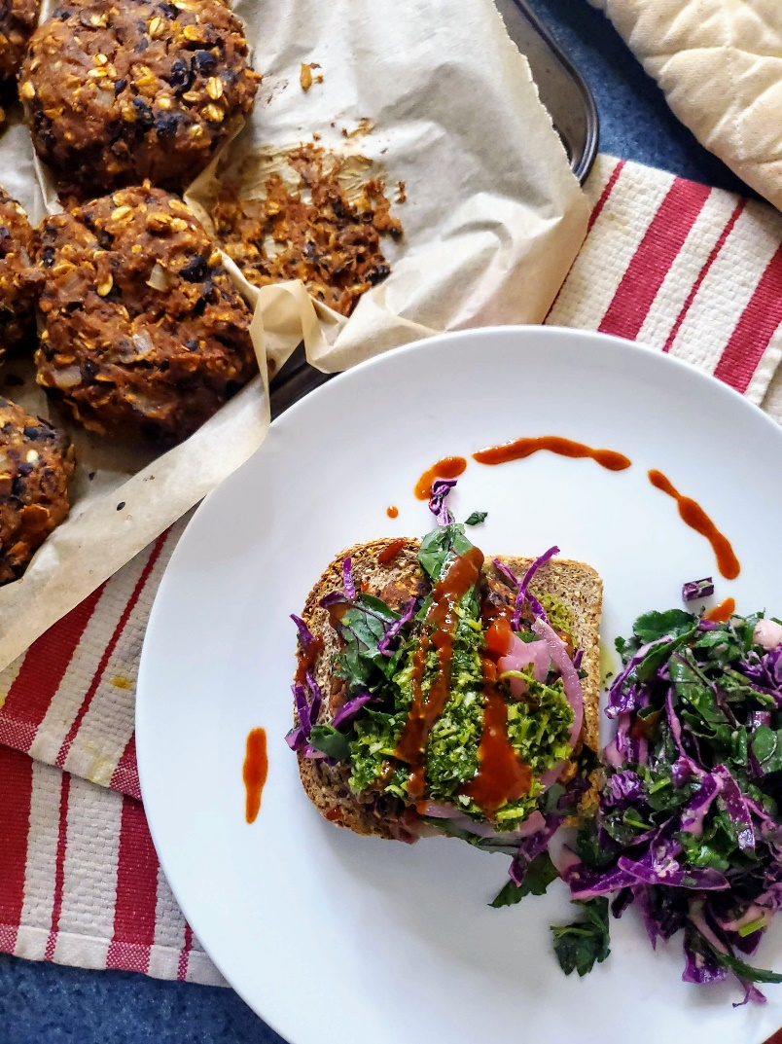

Suggested Meal Planner
WEEK OF: | BREAKFAST | LUNCH | DINNER
MONDAY | Super Green & Berry Smoothie | Chickpea Cranberry Walnut Salad | Sweet Potato Black Bean Burgers
TUESDAY | Homemade Granola with Plant Yogurt | Sweet Potato Black Bean Burgers | Minestrone Soup
WEDNESDAY | Ultimate 5-Minute Smoothie Bowl | Chickpea Cranberry Walnut Salad | Moroccan Chickpea Skillet
THURSDAY | Homemade Granola with Plant Yogurt | Minestrone Soup | Portobello Mushroom Fajitas
FRIDAY | Mango Ginger Berry Smoothies | Portobello Mushroom Fajitas | Moroccan Chickpea Skillet

BONUS: Chocolate Hummus

Lunch & Dinner Grocery List

- 1 ½ c Mixed Berries
- 1 Banana
- 3/4c Plant Milk
- 2 c Kale or Spinach
- 1 c Spinach
- 1 T Flax Seeds
- 3 T Hemp Seeds
- 1 T Peanut Butter
- 1 c Strawberries + Raspberries
- 2 c Frozen Mango
- 1 c Coconut Milk
- 1 Lime
- 1 T Chia Seeds
- 2 c Buckwheat Groats
- 4 c Rolled Oats
- 2 15 oz. cans Chickpeas
- 4 T Tahini
- 2 T Maple Syrup
- 2 T Cacao Powder
- 1 t Vanilla Extract
- 2 28 oz. cans Chickpeas
- 3 ribs Celery
- 5 Carrots
- 2 Red Onions
- 1 c Parsley
- 1 c Walnuts
- 1 c Dried Cranberries
- 1/3 c Cashews
- 3 Lemons
- 2 t Apple Cider Vinegar
- 2 T Tamari
- 1 Date
- 2 Sweet Potatoes
- 1 29oz. can Black Beans
- 3 head Garlic
- 3 ½ T Smoked Paprika
- 3 ½ T Ground Cumin
- 3 T Onion Powder
- 2 T Dried Oregano
- 2 T Garlic Powder
- ½ Green Cabbage
- 1 Apple
- ½ c Cilantro
- 2 t Red Wine Vinegar
- 1 T Mustard
- 1 28oz. can Crushed Tomatoes
- 1 15oz. can Kidney Beans
- 1 15oz. can Pinto Beans
- 3 Yellow Onions
- 3 Potatoes
- 1 bulb Fennel
- 8 c Vegetable Stock
- ½ c Dry White Wine (optional)
- ¼ c Basil
- 2 t Dried Thyme
- 3 Bell Peppers
- 8 oz. Portobello Mushrooms
- 1 Avocado (optional)
- 1 T Chili Powder
- 15 oz. Diced Tomatoes
- 2-3-inch piece Ginger
- 2 t Ground Ginger
- 1 t Ground Cloves
- 2 t Ground Cinnamon

BREAKFAST IDEAS

Ultimate 5-Minute Berry Smoothie Bowl
Cook and Prep Time: 5 minutes
Serves: 1
You Need
- 1 cup Mixed Berries
- 1 Frozen Sliced Banana
- 2 T Plant Milk of Choice
Toppings*
- 1 T Nuts or Seeds of Choice
- 1 T Dried Fruit
- Fresh Fruit of choice
- 1 t Chia Seeds
- 1 T Desiccated Coconut
- 1 T Nut Butter of choice
- Granola (optional)
*Feel free to mix and match toppings as you see fit!
DIRECTIONS
- To a blender, add bananas, mixed berries, and plant milk. Add more milk if necessary, but you want the mixture to be very thick.
- Place the mixture in a bowl. Top with your desired toppings.
- Serve and eat immediately. Enjoy!

Super Green & Berry Smoothie
Serves 1

Cook and Prep Time: 5 minutes

You Need:
- 2 cups Spinach or Kale
- ½ cup Mixed Berries
- 1 T Flax Seeds
- 1 T Hemp Seeds
- 1 T Peanut Butter
- ½ cup Plant Milk of Choice

DIRECTIONS
- Clean and prep the ingredients as necessary.
- Add all ingredients to blender.
- Pulse until smooth. Enjoy!

Mango Ginger Berry Smoothies
Serves 2

Cook and Prep Time: 5 minutes

You Need:
- 1 cup Frozen Raspberries & Strawberries
- 2 cups Frozen Mango
- 1 cup Coconut Milk (or other dairy-free milk)
- 1 Lime, juiced
- 2 T Fresh Ginger
- 2 T Hemp Seeds
- 1 T Chia Seeds
For serving:
- Shredded Coconut
- Coconut Yogurt
- Hemp Seeds

DIRECTIONS
- Clean and prep the ingredients as necessary.
- Add all ingredients to blender.
- Pulse until smooth. Enjoy!

Homemade Granola Template
Cook and Prep Time: 30 minutes
Serves: 5 portions
You Need
Basics:
- 2 cups Buckwheat Groats
- 3 cups Rolled Oats
Add On Ingredients:
- 1 ½ cup Nuts (walnuts, almonds, Brazil nuts, cashews, pecans, etc.)
- Dried fruit (apricots, dates, desiccated coconut, goji berries, cranberries, etc.)
- Herbs and Spices (cinnamon, nutmeg, allspice, ginger)
- Cacao Nibs
For Serving
- Fresh Fruit
- Dairy-Free Yogurt
- Dairy-Free Milk
- Nut & Seed Butters (almond, peanut, cashew, tahini)

DIRECTIONS
- Preheat your oven to 350˚F. Line 1 baking tray.
- Mix the buckwheat grouts and jumbo oats together, and add them to your baking tray.
- Bake the oats for 25 minutes, tossing halfway.
  - You want a nutty effect, but not burnt.
- Remove from the oven and let cool.
- Once cooled, add to a bowl. To that bowl, pour in your desired “Add On” ingredients, and toss to combine.
- Store in a mason jar until ready to serve.
- Add your favorite ingredients for serving. Enjoy!

Chocolate Hummus
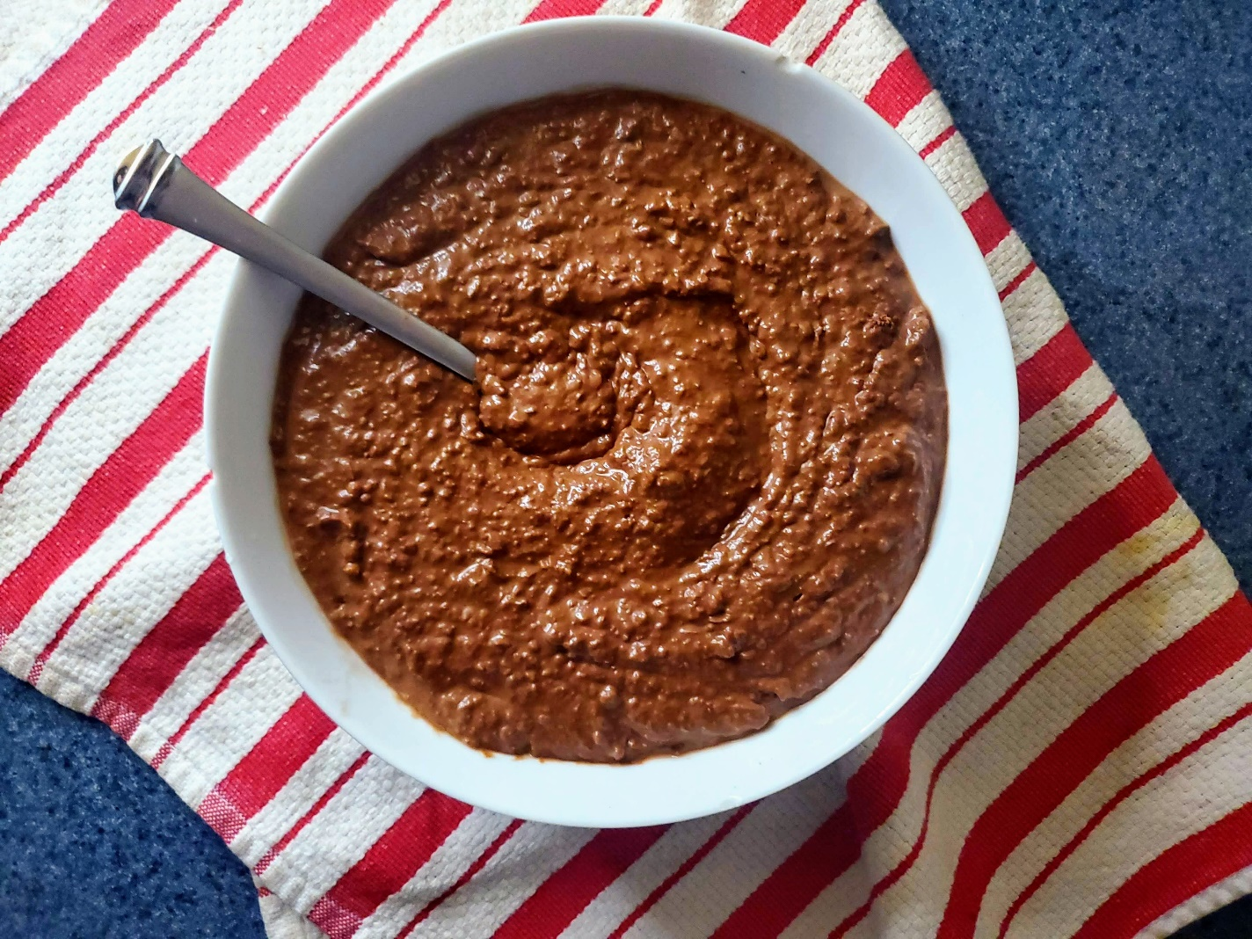
Cook and Prep Time: 5 minutes
Serves: 2 cups
You Need
- 1 15 oz. can Chickpeas, rinsed and drained
- 2 tbsp. Tahini
- 2 tbsp. Maple Syrup
- 2 tbsp. Cocoa Powder
- 1 tsp. Vanilla Extract
- 2 tbsp. Aquafaba or Non-Dairy Milk
DIRECTIONS
- Combine all ingredients in a food processor and pulse until smooth. Add more milk or aquafaba as needed.
- You can store in the refrigerator for up to a week in an air-tight container. Enjoy!

Chickpea Walnut Cranberry Salad
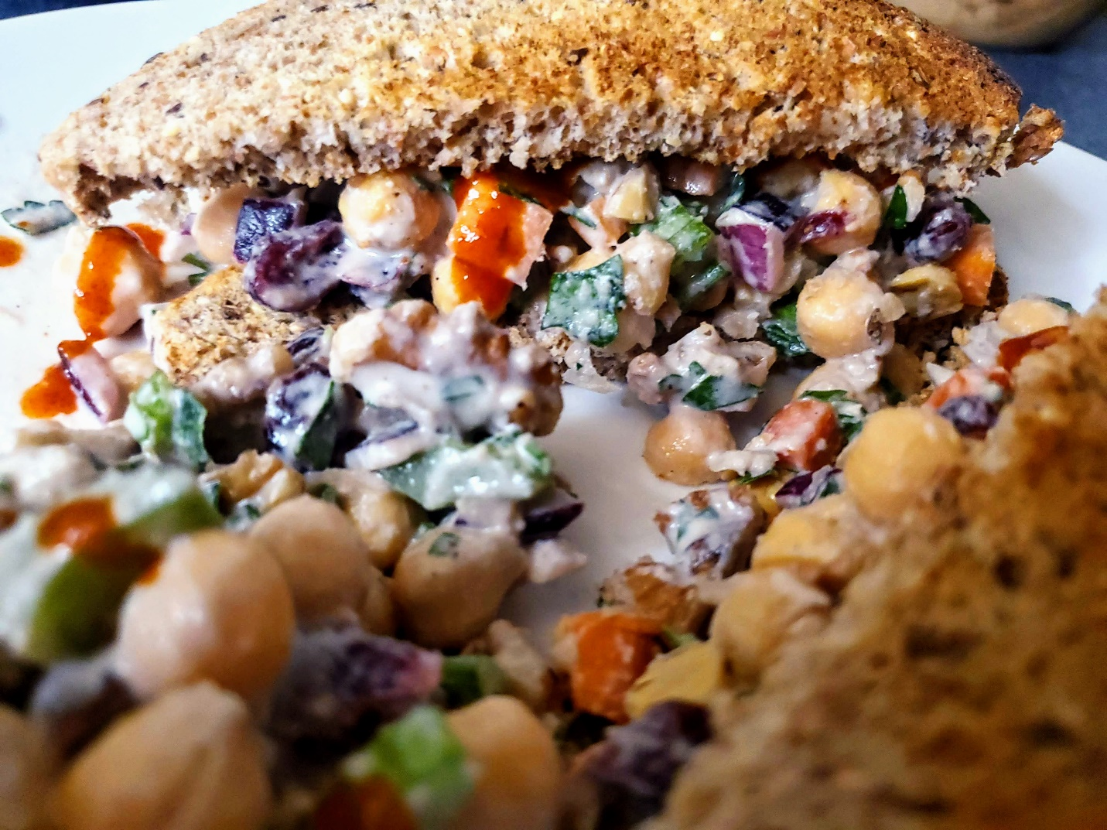
Cook and Prep Time: 15 minutes
Serves: 4-6
You Need
- 1 28 oz. Chickpeas, rinsed and drained
- 2-3 ribs Celery, diced
- 2-3 Carrots, diced
- ½ Red Onion, diced
- ¾ cup Parsley, chopped
- 1 cup Walnuts, chopped
- ¾ cup Dried Cranberries
- ¾ cup Vegan Mayonnaise (recipe below)
- Salt & Pepper, to taste
DIRECTIONS
- Rinse and chop the produce accordingly.
- Make the Vegan Mayonnaise (see below)
- Add all ingredients to a large bowl, and toss to combine.
- Add the Vegan Mayonnaise, and stir to coat evenly.
- Serve as a side or on and sandwich with hot sauce. Enjoy!
Vegan Mayonnaise
Cook and Prep Time: 5
Serves: 1 ½ cups
You Need
- 1/3 cup Cashews, soaked overnight
- ½ tbsp. Lemon Juice
- 2 tsp. Apple Cider Vinegar
- 1 tsp. Dijon Mustard
- 1 tsp. Tamari
- ½ Medjool Date, pitted
- ¼ tsp. Onion Powder
- ½ cup Water
- Salt, as needed
DIRECTIONS
- Rinse a prep the ingredients accordingly.
Add to a blender and pulse until smooth.

Sweet Potato Black Bean Burgers with Slaw
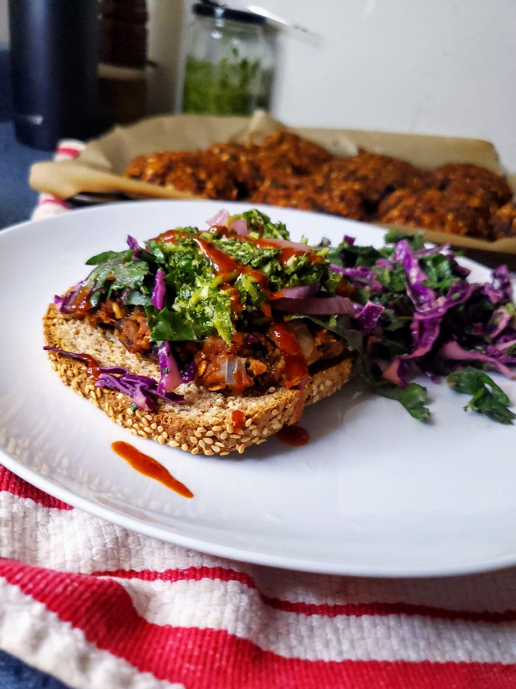
Cook and Prep Time: 1 hour
Serves: 8-10
You Need
- 2 Sweet Potatoes
- 29oz. Black Beans, rinsed & drained
- 1 Red Onion, diced
- 6-8 cloves Garlic, minced
- 1 cup Rolled Oats
- 1 T Smoked Paprika
- 1 T Ground Cumin
- 1 T Garlic Powder
- 1 T Onion Powder
- 2 t Dried Oregano
- 1 T Tamari
- Salt & Pepper, to taste
DIRECTIONS
- Rinse and chop the produce accordingly. Line 1 baking tray and preheat your oven to 400˚F.
- Cut the sweet potatoes in half lengthwise, and place face-down on the baking tray. Bake for 30 minutes, until fork-tender.
- Once the sweet potatoes cool, peel the skin and add them to a large mixing bowl, with the rest of the ingredients. Mix well, until evenly combined.
- Once mixed, form about ½ cup of the mixture into evenly-sized patties. Then, place them onto your lined baking tray. Then, bake for 25-30 minutes, flipping half way.
- Serve with toasted buns, salad, and your favorite burger toppings. Enjoy!

Cabbage, Green Apple, & Carrot Slaw
Cook and Prep Time: 10 minutes
3-4
You Need
- ½ Green Cabbage, shredded
- 1 Carrot, shredded
- 1 Granny Smith Apple, thinly sliced
- ¼ cup Chopped Cilantro, for garnish
For the Dressing:
- 1 ½ tbsp. Tahini
- 1 tbsp. Dijon Mustard
- 1 Lemon, juiced
- 2 tsp. Red Wine Vinegar
- Salt, to taste
- Black Pepper, to taste
DIRECTIONS
- Rinse and chop the produce accordingly.
- Place the cabbage, apples, and carrots in a bowl.
- In a smaller bowl, whisk together all the dressing ingredients.
- Add dressing to bowl and toss to combine.
- Garnish with chopped cilantro. Enjoy

Minestrone Soup
Cook and Prep Time: 60 minutes
Serves: 4-5
You Need
- 1 28 oz. can Crushed Tomatoes
- 1 15 oz. can Kidney Beans, rinsed and drained
- 1 15 oz. can Chickpeas, rinsed and drained
- 1 15 oz. can Pinto Beans, rinsed and drained
- 3 cups Onion, diced
- 3 Potatoes, cut into ½ inch pieces
- 3-4 cloves Garlic, minced
- 1 cup Carrots, diced
- 1 cup Celery, diced
- 1 cup Fennel, chopped
- ½ cup Dry White Wine (optional)
- 6 cups Vegetable Stock
- ¼ cup Basil, chopped
- 2 t Dried Oregano
- 2 t Dried Thyme
- Vegetable Stock, for sautéing
- Salt, to taste
- Black Pepper, to taste
DIRECTIONS
- Rinse and chop the produce accordingly. Save your basil for a garnish.
- Set a large pot to medium-high heat. Once hot, add onion, carrots, celery, and garlic. Cook until fragrant and softened, stirring frequently, for 5-6 minutes. Add tomatoes, fennel, potatoes beans, and chickpeas to the pot. Cover with vegetable stock or water (enough to cover all the vegetables by about 1 inch).
- Add spices, and bring soup to a boil, stirring to combine. Once boiling, reduce heat to a simmer. Cook uncovered for 20-30 minutes, until thickened.
- Serve soup with chopped basil as garnish. Enjoy!

Portobello Mushroom Fajitas
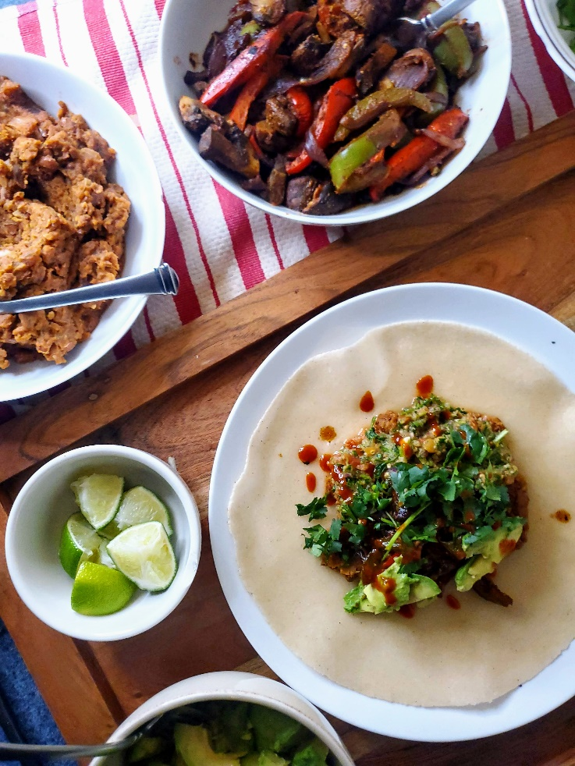

Cook and Prep Time: 25 minutes
Serves: 4-5 people
You Need
- 1 Yellow Onion, sliced
- 1 Red Bell Pepper, julienned
- 1 Green Bell Pepper, julienned
- 8 oz. Portobello Mushrooms, chopped roughly
- 1 tsp. Olive Oil OR Vegetable Stock, for sautéing
- 1 tbsp. Chili Powder
- 1 tbsp. Ground Cumin
- 1 tbsp. Garlic Powder
- 1 tbsp. Onion Powder
- 1 tbsp. Smoked Paprika
- 1 tsp. Dried Oregano
- 1 tbsp. Tamari
- Avocado, for garnish
- Lime Wedges, for serving
- Chopped Cilantro, for garnish
DIRECTIONS
- Rinse and chop the produce accordingly.
- Set a large skillet to medium-high heat. Add mushrooms and cook until mushrooms have released their liquid and has evaporated, about 5-7 minutes. Add tamari, and stir to combine.
- Then, add bell peppers and onions, along with the spices. Cook for 2-3 minutes, until flavors have combined.
- Serve with black beans or refried beans, avocado, lime, and chopped cilantro. Serve in warmed tortilla shells. Enjoy!

Moroccan Chickpea Skillet

Cook and Prep Time: 45 minutes
Serves: 4
You Need
- 2 cups Sweet Potato
- 28 oz. Chickpeas, rinsed and drained
- 15 oz. can Diced tomatoes, with juices
- 1 Bell Pepper, diced
- 1 Yellow Onion, diced
- 5-6 cloves Garlic, minced
- ½ inch piece Ginger, grated
- Vegetable Stock, for sautéing
- 1 Lemon juiced
- 1 bunch Spinach, chopped
- Salt & Pepper, to taste
- 2 cups Vegetable Stock (add more if needed)
Moroccan Spice Mix
- 1 ½ T Smoked Paprika
- 1 ½ T Ground Cumin
- 2 t Ground Cinnamon
- 1 t Ground Cloves
- 2 t Ground Ginger
Garnish
- Chopped Parsley
- Chopped Cilantro
- Chili Flakes
- Brown Rice or Quinoa (optional)

DIRECTIONS
- Rinse and chop the produce accordingly.
- Set a large skillet to medium-high heat. Once hot, add the onion and bell pepper. Sauté for 4-5 minutes until translucent. Then, add ginger and garlic. Sauté for another 1-2 minutes, until fragrant.
- Then, add the spices, tomatoes, chickpeas, and sweet potatoes to the skillet. Cover and cook for 30 minutes, or until the sweet potatoes are tender. Add more vegetable stock if the skillet is becoming too dry.
- Once cooked, uncover and add spinach and lemon juice. Stir to combine, and cook until spinach has wilted, 2-3 minutes.
- Divide into equal portions. Serve with your desired sides, and garnishes. Enjoy!

